Understanding and Improving Human Data Relations

Alex Bowyer

Table of Contents

# 1 Discussion II: Designing and Pursuing Better Human Data Relations

*“Civilizations advance not by the technology they know about, but by the technology they don’t have to know about.”* – Anonymous proverb

## 1.1 Introduction & Background

Through the Case Studies (Chapter 4 & 5) and the discussion in Chapter 6, a clear understanding of what people want from direct and indirect data relations (RQ1 & RQ2) has been established. In this chapter, we turn our attention from theory to practice, from what is needed to *what is possible*. Specifically, this chapter will return to the overall research question and consider *“How might [better Human Data Relations] be achieved?”*, and answer this question by describing practical approaches for future research, innovation and policy that are either novel or already emergent.

This chapter is deliberately broad and open ended. It does not pretend to be complete or definitive in its interpretation of the outlook for HDR. It is not a roadmap, but rather a snapshot of ongoing work, identified challenges and known opportunities, forming an **anthology of reference material**, based on my research and design experience from my six years working to understand and advance HDR.

The rationale here is that it will be valuable for anyone working in the HDR space to have a good high-level understanding of the landscape as well as specific ideas to work with; the goal is to boost and strengthen any such activities so that they might benefit from the insights gained.

The shape this chapter takes is to consider the the six HDR wants that this thesis has uncovered [Chapter 6] as a basis for defining **objectives** for the HDR landscape, then to to illustrate what specific **obstacles** and **opportunities** are relevant when attempting to pursue those objectives, as well as to highlight specific **designerly insights** that are relevant.

There are many aspects to the wide-reaching objective of better HDR in practice: technical, design, commercial, legal, moral, social and political and this chapter does not cover them all, nor is it formal empirical research. Instead, detail is provided in the form of **real world practical designs and insights** from four industrial and academic research projects I was part of during the same timeframe as the empirical research, as well as from the work of other innovators and activists. This detail is contextualised relative to existing literature and the thesis’ earlier contributions.

Some of the challenges and opportunities herein are described in greater detail than others, corresponding only to my proximity and depth of engagement with those ideas rather than their relative merit, complexity or impact potential. I consider that it is more useful to introduce a range of applicable ideas even if some are only lightly detailed, rather than to detail just a few.

In section 7.1.1 the peripheral R & D activities I undertook are described; forming the primary point of reference for this chapter, as this peripheral work has informed and allowed me to build upon the core HDR understanding from the empirial research, and much of the work has often aligned well to the six data wants [Chapter 6]. Often the work has exposed evolving areas where different actors are trying to bring about better HDR.

In section 7.1.2, I explain some important context about the nature of the ideas presented in this chapter and how to attribute them fairly.

In section 7.1.3, I introduce some additional background on *Theories of Change (ToC)*, which are used as a framing device for structuring the opportunities described in the main body of this chapter into a series of different possible trajectories for change.

In section 7.1.4, I consider the researcher-turned-activist stance that drives this chapter, framing the pursuit of better HDR as a *recursive public*.

In section 7.2, I formalise and expand the Human Data Relations concept. Additional insights into how people relate to data are identified, as well an important dichotomy of two distinct drivers that motivate people’s needs for better relations with their data.

Section 7.3 and 7.4 form the main body of this chapter, with obstacles and insights being detailed in section 7.3 and specific opportunities into how better Human Data Relations can be pursued in practice being described in 7.4. 7.4 identifies four specific trajectories of change (interpreted using the ToC frame described in 7.1.3). Within each of these four trajectories, specific named opportunities are described.

Section 7.5 concludes the thesis, summarising the change trajectories presented in 7.4, reflecting on my journey as a researcher and summarising the thesis’ contributions as a whole.

### 1.1.1 Peripheral Research & Design Settings

[TODO Move 3.4.3 etc. to here and remove all refs to 3.4.3]

The majority of examples and learnings shared in this chapter come from my participation as an expert researcher and designer in two industrial research projects:

1. **BBC R&D’s Cornmarket Project**, which explored through user experience design, technical prototyping and participatory research, how individuals might interact with data through a Personal Data Store interface (see 3.4.3.3)
2. **Sitra/Hestia.ai’s #digipower Project**, a successor to Case Study Two, in which European politicians examined companies’ data practices through exercising data rights and conducting technical audits (see 3.4.3.4)

In addition, my participation as an interface designer and front-end software developer in the following two academic research projects contributes secondarily to this chapter:

1. **Connected Health Cities (CHC)’s SILVER Project**, where I, along with a backend developer and a team of researchers, developed a prototype health data viewing interface for Early Help support workers (see 3.4.3.1).
2. **Digital Economy Research Centre (DERC)’s Healthy Eating Web Augmentation Project**, which explored the use of web augmentation techniques to modify the user interface of takeaway service Just Eat to insert health information, in support of healthy eating (see 3.4.3.2).

### 1.1.2 Attribution of Insights

While this thesis is my own original work, and many ideas presented in this chapter are fully original, some of the specific details, theories and ideas presented in this chapter arose or were developed or augmented through my close collaboration, discussion and ideation with other researchers, including:

* Jasmine Cox, Suzanne Clarke, Tim Broom, Rhianne Jones, Alex Ballantyne and others at BBC R&D;
* Paul-Olivier Dehaye, Jessica Pidoux, Francois at Hestia.ai;
* Stuart Wheater of Arjuna Technologies and Kyle Montague of Open Lab during the SILVER project; and
* Louis Goffe of Open Lab on the DERC Healthy Eating project
* earlier innovation work with Alistair Croll at Rednod, Montréal, Canada (circa 2011) and with Megan Beynon at IBM Hursley, UK (circa 2006).

Due to these collaborations and the ongoing and parallel nature of many of these projects to my PhD research, it is impossible to precisely delineate the origin of each idea or insight. In practice, ideas from my developing thesis and own thinking informed the projects’ trajectories and thinking, and vice-versa. These ideas would not have emerged in this form without my participation, so they are not the sole intellectual property of others, but equally I would not have reached the same conclusions alone, so the ideas are not solely my own either. All diagrams and illustrations were produced by me, except where specified, and the overall synthesis and framing presented in this chapter is my own original work. Where this chapter includes material from the four projects, that material is either already public, or permission has been obtained from the corresponding project teams.

### 1.1.3 Theories of Change

To provide a structure for cataloguing the insights conveyed by this chapter, I use a *Theory of Change (ToC)* framing. ToC is a set of methodologies is commonly used by philanthropists, educators and those trying to improve the lives of disadvantaged populations (Brest, 2010); the theories can be used in different ways including planning, participatory design and field evaluation of the effectiveness of new initiatives. There are many different implementations, but common to most of them is a focus on explicitly mapping out desired outcomes (Taplin and Clark, 2012) with a clear focus on who is acting and whether the change being brought about is a change in action, or a change in thinking (Es, Guijt and Vogel, 2015). In this chapter, ToC theory will be used in a very limited way, not as a methodology but simply to provide a structural frame for proposed changes, as described below. Using ToC to perform evaluation of the effectiveness of proposed change approaches in action in society would be well beyond the scope of this thesis. Nonetheless, this frame is a useful way to map out the different approaches to changing the world in pursuit of the ideal of better HDR.

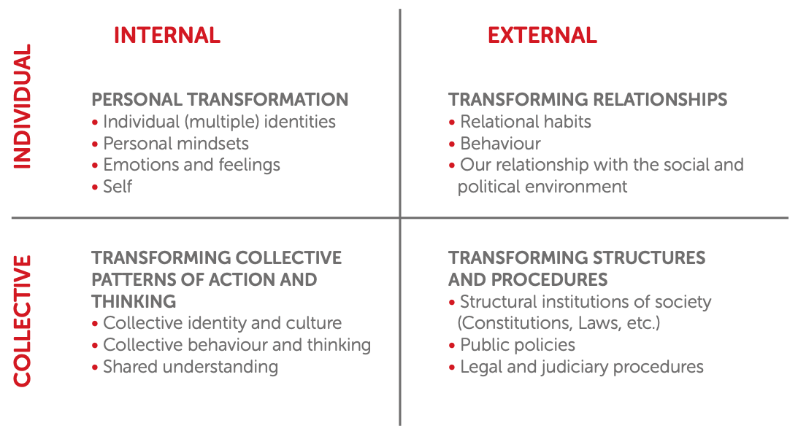

Figure 29: The Four Dimensions of Change[1]

Figure 29 illustrates the aspects of ToC thinking that section 7.4 will use as its frame. Specifically, desired changes can be broken down into:

* ***Internal changes***: changes in thinking, feeling, reasoning, understanding, attitudes or identity.
* ***External changes***: changes in actions, behaviour, interactions, structure, policy, technological capability, processes and the external environment.

At the same time, desired changes can be broken down into:

* ***Individual changes***: changes to individual thought or actions
* ***Collective changes***: changes to the thoughts or actions of groups of people together, or to the systems, practices and norms of society at large.

These two splits produce four dimensions of change, and form four quadrants representing different types of change, which are shown in Figure 29 and described here:

* ***Individual/Internal (II)***: This top-left quadrant represents changes to what individuals know and understand, and to how they think, feel and plan to take action.
* ***Individual/External (IE)***: This top-right quadrant represents changes to how individuals’ relationships with others; acting (or being enabled to act) differently in their daily lives and when interacting within society.
* ***Collective/Internal (CI)***: This bottom-left quadrant represents changes in the shared knowledge of groups of people or to the collective identity or values of social groups.
* ***Collective/External (CE)***: This bottom-right quadrant represents changes to the structures and procedures within which people operate, including technology, law, societal norms and communications.

Key to ToC thinking is the idea that making changes in one quadrant can stimulate change in others; for example, collective learning about data attitudes and practices, such as the research conducted in this PhD, (lower left quadrant) could inform the design of new technologies, interfaces or processes (lower right quadrant), which if built could make new structures available to have an impact on improving individual-provider relationships (upper-right quadrant). The changes to those relationships could then in turn lead to individuals thinking and feeling differently (upper left quadrant), for example feeling more empowered or having greater awareness of data practices.

## 1.2 Defining and Refining ‘Human Data Relations’ (HDR)

Chapter 6 established six ‘wants’ that people have in their relationships with data: **visible**, **understandable** and **usable data**; **process transparency**, **individual oversight** and **decision-making involvement**.

The major contribution of this thesis, beyond the detail and evidence for these wants conveyed in chapters 4 to 6, is to synthesise these findings and conceptualise what people want from data holders into a clearly defined field for future research and innovation. Repurposing the concepts of ‘human-technology relations’ and later ‘human-data relations’ which have been the subject of some study in the contexts of philosophy, embodied interaction and the performing arts (Ihde, 1990; Hogan, 2012; Windeyer, 2021), I have chosen to name this field ***“Human Data Relations”***, or HDR for short. I propose this field as a successor to Mortier *et al.*’s Human Data Interaction (HDI) (Mortier *et al.*, 2014). HDR builds upon HDI but is wider, broader and more sociotechnical; HDR encompasses all aspects of the ways in which people and organisations can and should relate to data, not just interaction with data itself. Through a greater focus on relationships and ecosystems and approaches that target today’s practical data-centric power-imbalanced reality, it can provide a more effective research agenda for the world of the 2020s. The field’s definition draws upon three distinct connotations or readings of its name:

| Human Data Relations - A Definition |
| --- |
| The field of human data relations encompasses all the ways in which humans and human organisations relate to, and with, data, specifically: |
| 1. **Human-Data Relations**: the direct interaction of users with data to understand and use it, similar to HDI, and in service of the **direct data wants** [6.1] of visible, understandable and useable data. |
| 2. **Human “Data Relations”**: the relationships that humans have with organisations that hold data about them, in service of the **indirect data wants** [6.2] of transparency, individual oversight and involvement. |
| 3. **Human/Data Relations**: the ways that organisations **manage their customers with respect to personal data**. Similar to *‘public relations’* or *‘customer relations’*, this concerns the ways that organisations present their data practices (so as to build trust), and the ways in which they could involve users with data and provide support to understand data to their users (in order to empower individuals and build more effective customer relationships) [4.4.1; 5.5.2; 6.1.2]. |

[TODO Format this as an inset box not a table]

Having defined the scope of HDR, we can say that ‘better’ HDR can be achieved by working to improve upon the identified six aspects of human data relations. However, as this section will explain, HDR is motivated in two distinct ways, to which those six wants apply differently. As background understanding for this duality of motivation, it is first necessary to examine more closely what role data plays in people’s lives.

### 1.2.1 The Role of Personal Data

In the modern world, where almost anything can be encoded as data, and given many previously analogue objects and activities now have digital equivalents, the concept of data has become broad and hard to pin down. Underlying Human Data Relations is to explain what roles data can play in people’s lives – what it **is** to people. Through the Case Studies, external work and my prior learning, I have so far identified 8 distinct lenses to consider how people might relate to it. These are modelled in Table 15.

Table 15. **Eight lenses on data**.

| Way of thinking about data | Explanation & Implications |
| --- | --- |
| Data as property | Data can be considered as a possession. This highlights issues of ownership, responsibility, liability and theft. |
| Data as a source of information about you | Knowing that data contains encoded assertions about you and can be used to derive further conjectures enables thinking about how it might be exploited by others, but also how you can explore and use it yourself for reflection, asking questions, self-improvement and planning. It invites consideration of the right to access, data protection, and issues around accuracy, fairness and misinterpretation / misuse. |
| Data as part of oneself | A photo or recording of you, or a typed note or search that popped into your head could be deeply personal. This lens on data highlights issues around emotional attachment/impact, privacy, and ethics. |
| Data as memory | Data can be considered as an augmentation to one’s memory, a digital record of your life. This lens facilitates design thinking around search and recall, browsing, summarising, cognitive offloading, significance/relevance, and the personal value of data. |
| Data as creative work | Some of the data we produce (e.g. writing, videos, images) can be considered as an artistic creation. This lens enables thinking about attribution, derivation, copying, legacy and cultural value to others. |
| Data as new information about the world | Data created by others can inform us about previously unknown occurrences in our immediate digital life or the wider world. This lens is useful for thinking about discovery, recommendations, bias, censorship, filter bubbles, and who controls the information sources we use, as well as who will see and interpret data that we generate and what effects our data has on others. |
| Data as currency | Many data-centric services require data to be sacrificed in exchange for access to functionality, and some businesses now explicitly enable you to sell your own data. This lens highlights that data can be thought of as a tradable asset, and invites consideration of issues of data’s worth, individual privacy, exploitation and loss of control. |
| Data as a medium for thinking, communicating and expression | Some people collect and organise data into curated collections, or use it to convey facts and ideas, to persuade or to evoke an emotional impact. This lens is useful to consider data uses such as lists, annotation, curation, editing, remixing, visualisation and producing different views of data for different audiences. |

When considering HDR, it is important to recognise that people may think of their personal data through any or all of these *‘lenses’* [Karger *et al.* (2005);2.2.2] at any given time, and any process or system design involving data interaction should take these into account.

Looking across this set of lenses, it is possible to identify four specific roles that data can serve:

1. Data has a role as an **artifact of value** to your life;
2. Data has a role in **informing** you about yourself, the world, and the prior or recent actions of others that may affect you;
3. Data has a role as **a usable material with which to effect change** in your life;
4. Data has a role as **a means to monitor changes** in data holders’ behaviours, digital influences upon you or changes within your life.

### 1.2.2 Human Data Interaction or Human Information Interaction?

To unpack HDR further, it is important to highlight the difference between humans relating to data, and humans relating to information. Human Data Interaction (HDI) concerns the way people interact with data. Mortier *et al.* (Mortier *et al.*, 2013, 2014) defined the field of HDI without distinguishing data (the digital artifact stored on computer) from information (the facts or assertions that said data can provide when interpreted). This is an important distinction. The parallel field of Human Information Interaction (HII) originated in library sciences, and considers the way humans relate to information without regard to the technologies involved (Marchionini, 2008). William Jones *et al.* called for a new sub-field of HII in an HCI context[2], observing that it is important to include a focus on information interaction because HCI can *“unduly focus attention on the computer when, for most people, the computer is a means to an end – the effective use of information”* (Jones *et al.*, 2006). DIKW theory [2.1] highlights that **interpretation of data to obtain information** is a discrete activity. This was borne out in the findings of Case Study Two, where it became clear that participants have distinct needs from data, and from information (5.4.3.2). Access to data **and** information is critical to both understanding and useability, as detailed in section 6.1.2 and 6.1.3.

Drawing on this theory, we can see then that in considering Human Data Relations, there are in fact three distinct artifacts to consider:

1. ***data*** - the stored digital artifacts pertaining to users held by organisations for algorithmic processing and human reference, copies of which can be obtained using individual data rights.
2. ***information about individuals*** - the collection of facts and assertions about the individual and their life, which are obtained through human or algorithmic interpretation of stored data (or in some organisations’ case, through analytical inference).
3. ***information about data*** (also categorised in Table 9 / 5.3.1 as ***metadata***) - stored facts about the data, such as where it has been stored, who has accessed it, how it was collected, what it means, or when it has been shared externally.

### 1.2.3 The Two Distinct Motivations for Human Data Relations

By making this distinction between the two types of information which people might interact with, and considering the six wants in Chapter 6, it becomes clear that there are two very different reasons why people might want better HDR:

1. to acquire *information about one’s* ***data***, so that one might exert control over and make informed choices about where *the data* is held and how it is used, in order to be treated fairly and gain more control over the use of one’s personal data. This is **Personal Data Ecosystem Control (PDEC)**.
2. to acquire *information about oneself*, so that one might gain insights into one’s own behaviour and gain personal benefits from those insights or them to make changes in one’s life. This is **Life Information Utilisation (LIU)**.

The two distinct processes that individuals might go through in pursuit of these motives are exemplified in Figure 30. PDEC is a process of holding organisations to account over and managing *what happens to personal data*, often regardless of what it means, whereas LIU is more concerned with *what the data means* and its inherent value as encoded life information, regardless of where it is stored and how it is used[3]. This novel way of modelling the motivations for data interaction were first proposed in my 2021 workshop paper (Bowyer, 2021).



Figure 30: The Two Motivations for HDR: Controlling your personal data ecosystem and utilising your information about your life, with ‘idealised’[4] processes illustrated

#### 1.2.3.1 Life Information Utilisation

***Life Information Utilisation*** is a superset of *Self Informatics (SI)* 2.2.3. It includes all purposes relating to self-monitoring and self-improvement through data, but also includes all other uses of personal data including creative expression, evidence gathering, nostalgia, keeping, and sharing. Many of these desires were expressed in Case Study Two (see Table 12 in 5.3.3), and also hinted at in the Early Help context [4.4.1]. While the existence of digitally-encoded information clearly unlocks new possibilities, LIU has existed in some form throughout human civilisation, as seen through analogue processes such as storytelling, journalling, scrapbooking, arts and crafts.

In the LIU context, the most important wants to focus on improving are *data understandability* (6.1.2) and *data useability**15* (6.1.3), which relate closely to the HDI concepts of *legibility* and *agency* respectively.

#### 1.2.3.2 Personal Data Ecosystem Control

Unlike LIU, ***Personal Data Ecosystem Control*** is an individual need that is new; arising as a result of the emergence of the data-centric world (2.1, 2.2.4). Only when organisations began to collect and store facts about people as a substitute for direct communication and involvement did it become necessary. The more data is collected about individuals, and the more parties collect and share that data, the greater the need for individuals to learn about that data so that they might influence its use (or risk their lives being affected in unexpected or potentially unfair ways). PDEC is a direct response to the power imbalance between data holders and individuals that the World Economic Forum described in 2014 [Hoffman (2014);2.1.2].

In the PDEC context, multiple data wants are important: visible data and transparent processes, as well as individual oversight and involvement. For simplicity, the former two wants can be referred to collectively as *“ecosystem transparency”*, and the latter two as *“ecosystem negotiability”* (drawing on the HDI concept of *negotiability*), and these terms will be used below.

### 1.2.4 Better Human Data Relations as a Recursive Public

Before engaging with the practicalities of pursuing change, it is valuable to revisit the stance from which we approach this change. As outlined in 3.2, the research of this PhD has been grounded in participatory action research and experience-centred design; by using a Digital Civics (Vlachokyriakos *et al.*, 2016) frame to gain deep understanding of people’s needs and the ways those needs are not fully met, we can see how the world needs to change. Section 3.2 already outlined that we can consider such research as political, seeking to correct an imbalance in the world. In this chapter, we look beyond identifying what change is needed, and step into the role of activist, exploring how individuals and groups can actually change the world they inhabit.

In doing so, we can consider ourselves (those who pursue better Human Data Relations, or *HDR reformers* as a shorthand) as a *recursive public* (Kelty, 2008; ‘Recursive Public (Discussion Page)’, no date), albeit a nascent one. This is a term originating in the free software movement to describe a *“collective, independent of other forms of constituted power, capable of speaking to existing forms of power through the production of actually existing alternatives”*. This term captures the idea that through various means at our disposal: participatory research, experience-centred design, engineering software prototypes, exertion of legal rights, and efforts to raise public awareness, we seek to modify the systems and practices we live within in pursuit of our goals. This collective around better Human Data Relations does not yet exist as a named and identifiable *public* (Le Dantec, 2016) but its members congregate around emergent collectives in interconnected and overlapping spaces, most notably the MyData community (MyData, 2017) and its members, but also research and activism agendas including but not limited to: digital rights (‘Open rights group: Who we are’, no date), gig economy worker rights (Kirven, 2018), privacy by design (Cavoukian, 2010), data justice (Taylor, 2017; Crivellaro *et al.*, 2019), critical algorithm studies (Gillespie and Seaver, 2016), humane technology (Harris, 2013) and explainable AI (‘Explainable AI: Making machines understandable for humans’, no date).

Whether these disparate groups coalesce into a single identifiable public remains to be seen, and so too whether the term this thesis offers of *Human Data Relations* is sufficient to capture that public (at least, it provides a descriptive umbrella term). Nonetheless, the breadth of research and innovation and activism happening in this space validates both the need and the desire for such a recursive public around better HDR to exist. Therefore, this chapter takes an unashamedly critical view of the status quo, favouring disruptive societal changes that would further the objectives of better Human Data Relations and providing actionable approaches that will be of use to the members of this public. The chapter asks, “How can we change the world into the one we want?”

## 1.3 The landscape of opportunity: Obstacles to better Human Data Relations, and how we might overcome them

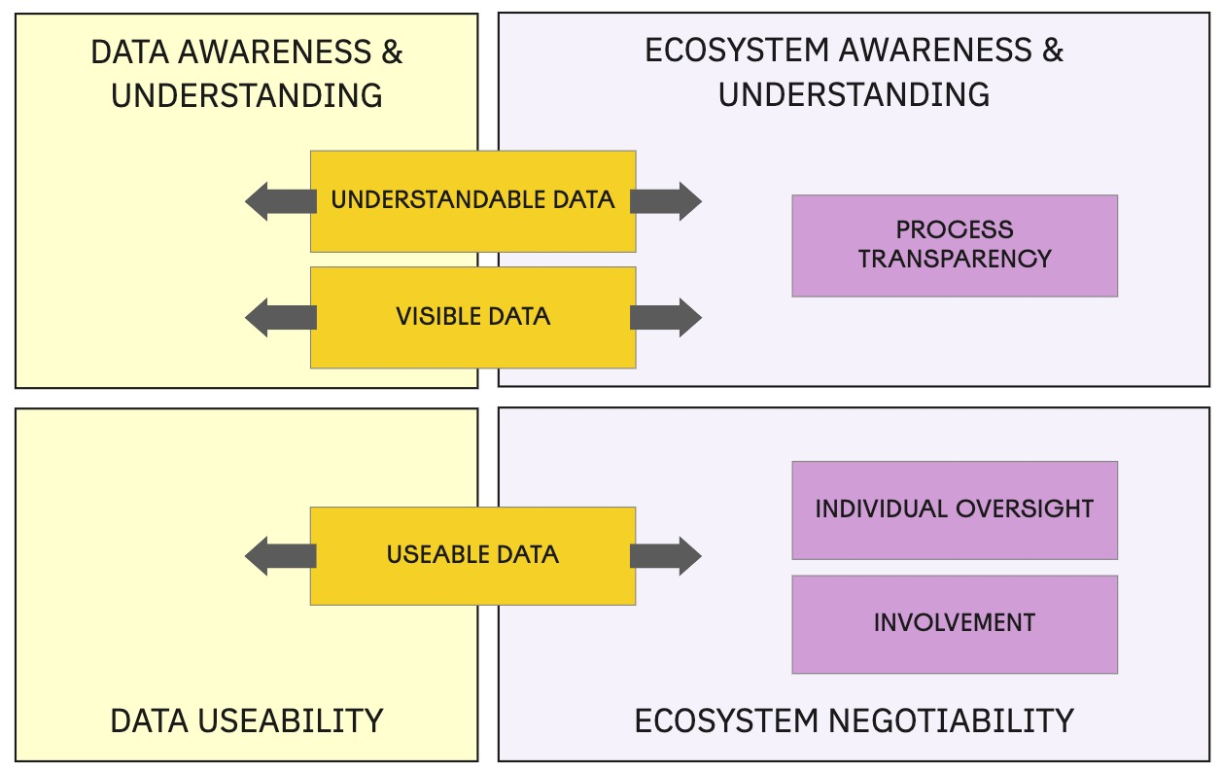

Figure X: Mapping the Six Wants into Objectives for the HDR Opportunity Landscape

In order to provide value to future researchers, activists and innovators, this chapter contributes a map of the HDR opportunity landscape. This map is expressed in two parts across this section and 7.4. As a first step, we can take the “six wants from data relations” Chapter 6, and map reduce those to four simple *‘landscape objectives’* which shape our ultimate goals for effective HDR in this landscape of opportunity:

1. Data Awareness & Understanding;
2. Data Useability15;
3. Ecosystem Awareness & Understanding and
4. Ecosystem Negotiability.

As Figure X shows, the need for data to be understandable, visible and useable, applies to all types of data, whether that data is interpretable as **life information** (information within the data, that says something about the individual) or **ecosystem information** (information *about* the data, where it is held and how it is used). These two types of information will collectively be referred to as **human information**, and will be used in describing the HDR landscape in subsequent sections.

Using these four objectives as our goals, and considering how they might be tackled, specific *obstacles* have been identified. These are analogous to Li’s ‘barriers cascade’ [2.2.3;#li2010] and represent the obstacles that individuals or system designers must be empowered to overcome if the objectives are to be met. These obstacles are followed by useful *insights* I have identified that might help overcome those obstacles. This is summarised in Figure X, which shows an HDR-specific barriers cascade: a route of overcoming obstacles through which individuals might be empowered and by which organisations might become more HDR-friendly.

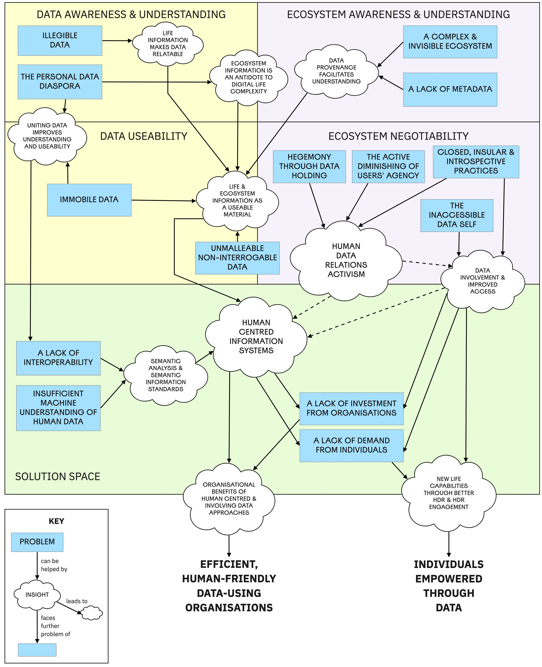

Figure X: Obstacles and Resulting Insights in the HDR Opportunity Landscape

The obstacles and insights in the figure are explained in the following subsections. The last of these (corresponding to the ‘solution space’ box) covers some of the more pervasive obstacles that apply to all of the previous four HDR objectives.

### 1.3.1 Obstacles to the HDR Objective of Data Awareness & Understanding

In pursuit of visible, understandable data [6.1.1; 6.1.2], the first obstacle encountered is that in today’s complex digital landscape, **most personal data is invisible, inaccessible or unrelatable**. It is trapped in service providers’ databases, or on different devices or hard drives, or inaccessible due to software limitations or proprietary file formats (Abiteboul, André and Kaplan, 2015; Bowyer, 2018), or in formats. Participants of both Case Studies talked of ‘not knowing’ what data exists and of being ‘in the dark’. As Case Study Two showed, even where data is accessible, it is not relatable (‘legible’ [Mortier *et al.* (2014); 2.3.2). Thus the objective here is to tackle this obstacle and ensure that people not only have awareness of their data, but can understand (‘make sense’ [Gurstein (2011); 2.1.4]) of what it means.

| **INSIGHT: Life Information makes Data Relatable** |
| --- |
| In the pilot study and Case Study One, ‘data cards’ were used to represent common types of civic data [Figure 8?X]. In Case Study Two [ADD REF to Types diagram in 3.X], and in Hestia.ai’s digipower investigation (7.1.1), categories of provider-held data were illustrated with examples. In my research report for BBC Cornmarket [ADD REF], the use of **relatable examples** was identified as an important way to help people understand what a piece of data represents.Recalling that to make data meaningful, we must be able to interpret it as information [2.1.1, this can be refined further: **To make data meaningful, it needs to be expressed as life information**. Tables, spreadsheets and ‘big data’ sound dry and (to some) dauntingly technical, but once those same datapoints are expressed as *‘facts about your life’*, the hurdle of relatability is overcome. The application (and effectiveness) of this principle is evident in successful online services like Netflix, Spotify and Strava, and in social media platforms like Facebook: these interfaces show understandable everyday concepts like Friends, Events, Movies, Playlists, not files, records, folders or database rows. These examples have successfully *‘pushed the technology into the background’*, in line with Weiser’s vision (Weiser, 1991), Rogers’ calm computing, and the quote that opens this chapter. While exploring this idea of mapping *life concepts* further at BBC R&D, I produced Figure X, which shows a near-exhaustive overview of the many different pieces of information in an individual’s life that might be held as data by service providers: |
| Figure X: Life Concept Modelling |
| This diagram shows how most common personal data types handled by providers today can be mapped to more relatable life information concepts. These life concepts (illustrated with examples where possible) are the best way to make data meaningful and relatable to individuals, and to begin to help people in their search for value in their data [5.4.3.1]. |

[TODO make this an inset box not a table] [TODO Fix non showing caption]

Another important obstacle to consider here is what I call the *Personal Data Diaspora*[5]. As illustrated by Imogen Heap’s quote opening Chapter 1, an individual’s personal data is typically very widely dispersed. For example, if I consider just my movement tracking data, I have over time accumulated activity logs from walking, running, cycling, and driving which are stored by Nike+, MyFitnessPal, Strava, Google Fit, Fitbit, Apple Health and Google Maps, not to mention the records remaining on my different smart watches, smartphones and hard drives. This is the problem of Integration (Li, Forlizzi and Dey, 2010) that SI enthusiasts face [2.2.3]. Even aside from the issues this creates in terms of managing one’s data ecosystem [2.2.4], it means that it is impossible to view the history of my physical activity side by side, to spot patterns over time or make comparisons. To overcome this obstacle, approaches to data interfaces and life information modelling must be identified that recognise the **scattered, complex reality of each individual’s personal data ecosystem** and begin to make it visible and understandable. This is explored further in 7.3.3 and 7.3.4 below.

The takeaway for this HDR objective is that data awareness and understanding is a problem of representation. Invisible data should be visibly represented, and all data should be represented in the context of its interpretation as life information.

### 1.3.2 Obstacles to the HDR Objective of Data Useability15

To consider how to improve the useability of data, we must first consider what properties of data, as it typically exists today, make it hard to use. The primary obstacles are that **most personal data is immobile, inaccessible, unmalleable and not interrogable**.

It is **immobile**, in that it is very difficult to move a dataset out of the environment where it exists: most data exists in organisations’ internal databases, where it is tightly coupled to technology stacks, interfaces and business processes that use it.

[TODO possibly move this paragraph elsewhere to avoid repetition with previous section] This setting of personal data also explains why it is **inaccessible** to individuals (in the sense of ‘effective access’ (Gurstein, 2011)). Data access requests such as GDPR are typically satisfied by creating a copy of the data, which creates problems of delay, divergence and understanding. Even then, as Case Study Two showed, this is incomplete [5.4.2.2] and much of the data is never made available. Its accessibility is also hindered by the technical nature of data. For organisational efficiency, data will often be stored in complex proprietary structures which are designed for the algorithmic efficiency of the specific operations the service provider wants to perform, rather than for general-purpose re-use.

Evident from individuals’ goals for use of their data [Table 12] is that people need to be able to ask questions of their data. This highlights the problem that data is not **interrogable**. It must stand for itself, and there is no obvious way to ask a question about the meaning of the data or about what the data says about a particular question, without either the co-operation of the data holder, or advanced technical skills in querying and data analysis. To be able to ask questions of data, it needs to be malleable - one needs the ability to break it down, look at it from different perspectives, and reconstitute it in different ways. This requires more than just an ability to produce visual representations of the data, but an ability to **interact with the data** and produce new interpretations and insights that can help to answer specific questions.

To overcome these obstacles, we need to find ways to extract data from its current constraints into environments where it can move freely and be examined and reconstituted without restriction.

To address these obstacles, the following insights could help:

| **INSIGHT: Data Needs to be United and Unified** |
| --- |
| It is clear that better HDR involves recognising this scattered, splintered reality (Lemley, 2021) and moving beyond it. To make data useable for individuals, the diaspora must be united. This means that data from different sources must first be **united** – brought together – and then **unified**, which means making it into a collection of data about the individual and their life, rather than scattered slices of that person’s life held separately in ways that are optimised for specific services. This is a multi-faceted sociotechnical problem of access, interpretation and **integration** (as recognised in self-informatics [Li, Forlizzi and Dey (2010); [2.2.3]]). The negotiability aspects are important (we can only unite data that we can access, and only those that stored information can fully explain it) but these aspects will be explored in 7.3.3 and 7.3.4 below. Setting that aspect aside and focusing on the practical, the way ahead begins with creating a space where data can be held, combined, controlled and **owned** by the individual - *‘place for your personal data’* (Jones, 2011, p. [2.2.4]), forming the seed of their new human-centric personal data ecosystem. This is in line with Bergman’s *‘subjective classification principle’*: that *‘all related items should be classified together regardless of technological format’* (Bergman, Beyth-Marom and Nachmias, 2003) (We could add: _‘regardless of where they are held’). This vision is embodied in the concept of **Personal Data Lockers** or Vaults (PDVs) [2.3.4]. The BBC R&D Cornmarket project [7.1.1] is one project which is examining how to build PDVs, and in section 7.4 I explore possible design approaches. At this stage, we must recognise the importance of the *concept*, though. Once data is united and unified, this enables the creation of new views of data that were not previously possible. For example, today each separate TV app, device or streaming service maintains separate records of what you have watched. Once unified in a PDV, it would be possible to present you with a unified view of all the past content you had viewed, across all channels, as this mockup I made at the BBC shows: |
| Figure X: A mockup of a unified TV viewing history which I created for the BBC R&D Cornmarket project |

[TODO make this an inset box not a table]

| **INSIGHT: Data Must Be Transformed into a Versatile Material** |
| --- |
| Looking at the specific individual goals Case Study Two participants had with personal data [Table 12] (e.g. reflection, pattern-finding, goal-tracking, and creative use) - and also at the many mechanisms that innovators in the PIM space have identified [2.2.2] (e.g. associative exploration, spatial arrangment, embodied interaction for different contexts), what we can infer is that somehow, unified data must be **transformed into a versatile material**. To truly empower users to make use of their data, we need to move to a model where data - represented as facts (or assertions) about their life – can be created, deleted, moved, grouped, annotated, copied, shared, modified, labelled, organised, separated or otherwise manipulated. This idea of data being a material is new for everyone but data scientists: it is new not just to end users but for designers too. Eva Deckers, in her work on *data-enabled design*, an approach to design which also calls for data to become a material, notes that designers (and we could expand this to laypeople too) *“are in general not trained and prepared to work with data. They’re not equipped with the right tools, data manipulation is not part of the schools’ curriculum and designers [people] are rarely interested in understanding data”* (Deckers, 2018). Her work with colleagues on the ‘connected baby bottle’ illustrated hows how such an approach can create a space for the iterative user-centred development of new capabilities (Bogers *et al.*, 2016). Based on this thesis’s theorisation of human data relations, the best candidate for what this material should *be* is the two information concepts we have identified - life information and ecosystem information. So the goal of data useability calls for the creation of **systems that enable human information to be treated as a material**. |

So, for data to be useable, we must change its nature. We have been trained by the computers that have existed up to now that the basic units for interacting with computer systems are files - these are the material of today’s personal computers. Where we do interact with data as information instead of files, that information is typically presented in limited contexts within certain products or apps. In line with the goal to move up the DIKW pyramid [2.1], we need smarter computer systems, that move beyond files (Bowyer, 2011) - systems whose basic units of interaction are pieces of human information. **We need a human information operating system**.

### 1.3.3 Obstacles to the HDR Objective of Ecosystem Awareness & Understanding

As I have established in 2.2.5, 2.3, 6.2 and 7.2, human data relations cannot be made effective without a sea change in the way that individuals are able to interact with the complex ecosystem of personal data that we each inhabit. **Our personal data ecosystems are incredibly complex and largely invisible**. For example, it is very easy to allow a handful of communication and social media apps access to your address book or contact list, and before you know it you have created a complex and unmanageable network of connections that silently sync and propogate your addresses and phone numbers across the Internet. And there are deeper layers which are not even slightly visible to users: networks of data brokers, advertisers and digital cookie companies exchange user identifiers, activity data and personal information about you while you browse or use apps (Pidoux *et al.*, 2022). As the Case Studies showed, the ability to to build up a meaningful picture of your personal data ecosystem is completely absent [4.3.4.1] or severely limited, causing people to remain *‘in the dark’* and leads to feelings of fear (Bowyer *et al.*, 2018), overload [2.2.4] and resignation [5.4.4.1]. Managing one’s personal data ecosystem is an **overwhelming, unmanageable task** that even personal data experts are not fully able to get a handle on. We do not feel *‘in control’* [Teevan (2001); 2.2.2]. The ability to provide a user with ecosystem transparency is hindered by the complexity and multiplicity of the data relationships they have been encouraged to set up, and by a lack of tools to provide a meaningful, or indeed any, view of those relationships. A further aspect to this obstacle is that in both Case Study contexts, no one individual or organisation has the ability to see the whole of a user’s data ecosystem [4.3.4.3; Cornford, Baines and Wilson (2013)], and there is little commercial motive to try and solve this problem, as every provider focuses just on their own apps, websites and services. Making one’s ecosystem visible, transparent and understandable is therefore an essential objective for better HDR.

| **INSIGHT: Ecosystem Information is an Antidote to Digital Life Complexity** |
| --- |
| Having identified that acquiring ecosystem information and understanding is a key motivator for many people (constituting 74% of participant goals in Case Study Two [Table 12]) and is an essential objective for better HDR, we can view the building of systems for **ecosystem detection** and **ecosystem information display** as ingredients to help overcome the obstacle. As a representative example to help show what this could look like, we can look to a new app called SubsCrab, pictured in Figure X. |
| Figure X: SubsCrab: An example application for ecosystem detection and visualisation |
| This app connects to the user’s e-mail account, and searches it and monitors it for e-mails from service providers such as Netflix, Spotify, Dropbox, or Google with which the user has monthly subscriptions. In doing so, it is **detecting part of the user’s ecosystem** - identifying which companies they have a payment relationship with, and parsing the e-mails to identify billing dates and payment amounts. It then **provides additional representations of that ecosystem information to the user**, so that they might get on top of their subscriptions, see what they need to pay (or cancel), and feel more ‘in control’ [Teevan (2001); 2.2.2] of this aspect of their digital life. Thanks to this illustration it is easy to imagine other types of ecosystem detectors, for example detecting relationships with free services and websites, identifying account numbers and e-mail addresses, password resets, addressbook syncs, OAuth logins, family identities and more. Each of these could then power new interfaces, contributing to the **simplification of the user’s digital life** and **giving people more visibility and control** over their previously unmanageable data ecosystem. |
| A further interpretation from this insight is that a key element of the required ‘sea change’ in approaches to human information relations mentioned above, is to challenge the current life-information-centric model that pervades in PDV and SI approaches, which all **assume that the only way to unite data is to collect it**. The difficulty in such an approach is that you can only collect that which you can extract. To address this, I drawing inspiration from a computer programming concept known as *‘pass by reference’* (as opposed to *‘pass by value’*) (Ananya, 2020) where data is ‘pointed to’ rather than moved and also from productivity guru David Allen who recommends the use of *‘placeholders’* (Allen, 2015) to keep track of tasks you cannot otherwise bring into your planning. To be able to build a complete map of a user’s ecosystem we must **be able to keep track of accounts and data that are remote**, much like a search engine points to information on different pages around the web. We can create **proxy representations of service-provider-held or otherwise inaccessible data** (e.g. offline or restricted). These representations can become part of the manipulable material in the user interface, and could be augmented with links to visit those remote services. |

Once we begin to think about storing and representing human information in ways that go beyond simply representing the information that is encoded within the data, and into the realm of *what the data is about*, new possibilities are unlocked. We can envisage building a PDV type system that is not only a repository of personal data, but (thanks to proxy representations), a collection of ecosystem information *and* *contextually-situated* life information too, including information about relationships with data holders or other entities. This, however, exposes a secondary problem that any builder of such a system would face: **a lack of metadata** (as discussed in 2.2.2). Typically, much of the information stored on our hard drives lacks context about where it has come from, and how it relates to the individual in a holistic life/ecosystem sense. Where data access rights are executed (or data is shared via human means such as in 4.3.2.2), the attention is on the data itself: what it says. Case Study Two showed that some of the most desired information was not the data itself, but how it is used and shared and what is inferred from it (i.e. **metadata** [Table 9]), yet this was rarely forthcoming [Table 10]. There are many facets that can be quantified and recorded about a datapoint or dataset, as illustrated in Figure X, which I created at BBC R&D:

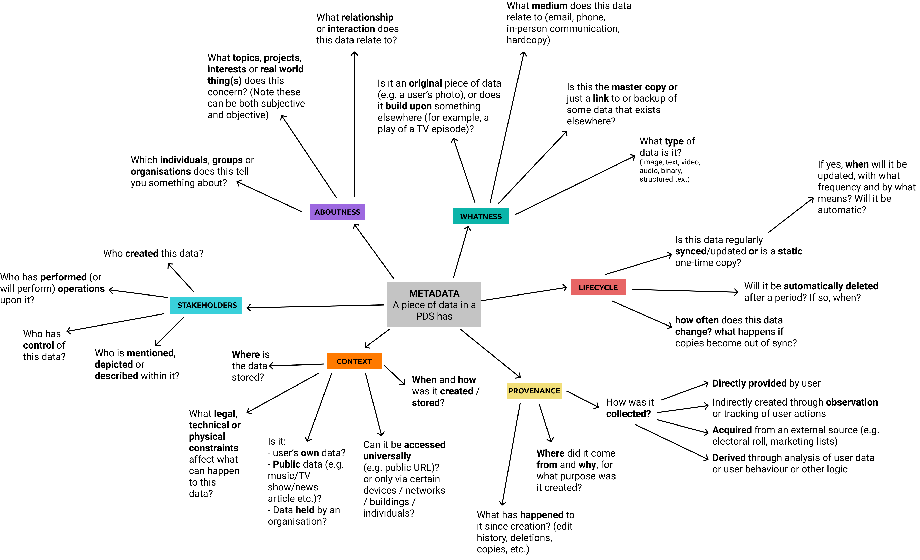

Figure X: Some of the many aspects of metadata that might exist about a datapoint or dataset

It is notable that many of these facets are not explicitly recorded today, or would take significant work to capture; nonetheless, this exploration can serve as a useful reference for how information can be better contextualised (supporting context-based and associative information management as described in 2.2.2). Taking a step back to view this lack of metadata at a more conceptual level, leads us to the next insight:

| **INSIGHT: We Must Know Data’s Provenance** |
| --- |
| Metadata is what gives information *context*, which is critical to sensemaking [2.2.3] and enables good experience-centred design [2.3.2, 2.3.3]. Without context, data loses meaning (as observed by a participant in Case Study Two [5.4.3.1]). Collecting historical data about the individual is important from an SI reflection perspective [2.2.3]), but knowing the **history of a piece of data** is vital to understanding its nature and context. Data is not neutral and in fact is inherently biased, since it was created for a specific purpose with a specific agenda in mind (Gitelman, 2013; Neff, 2013). To address this, more context is clearly needed, Significant research in this space has been undertaken by Professors Mike Martin and Rob Wilson at Northumbria University, formerly Newcastle University, who promote the idea of ***data with provenance***; in other words that **data must carry with it the details of why it exists, how it came to be, and what has happened to it since its inception**, and that provenance must be communicated alongside any visualisation of the data, in order for it to be fairly assessed through full understanding of its context. Provenance is essential for data to be trusted, argues Martin, and should be quite granular: a piece of data should be attributed not just to an individual or organisation, but to the relationship between role-holding individuals in a specific context, and greater insights can be gained when **considering all actions upon data as motivated communications from one party to another**; only by capturing this information in-situ can the data be fully appreciated (Martin, 2022). This framing essentially advances the concept of history tracking into the sociotechnical, ecosystem-aware problem space this section is addressing. While everyday system designs have not approached this level of granularity, the importance of data provenance has been recognised in the PIM space: As described in 2.2.2, temporal PIM systems, from Lifestreams (Freeman and Gelernter, 1996) to activity streams (Hart-Davidson, Zachry and Spinuzzi, 2012) rely upon data provenance in some form. A study by Jensen *et al.* concluded that provenance tracking can be valuable for identifying related documents, a critical part of knowledge work today (Jensen *et al.*, 2010). Odom, Lindley and colleagues proposed the idea of file biographies, which view the lifetime of a file as something that should remain connected, and can be traversed in order to understand the context of the file at its different interaction points (Lindley *et al.*, 2018). This comes close to Martin’s vision but does not capture the motivation for each interaction. While provenance capture is not a solution in its own right to the understanding of data and of ecosystems, it is clear that data with provenance is very likely to be a valuable part of any design that aims to help individuals with managing to get an overview of their complex and invisible personal data ecosystems. |

What we can see in this section is that by paying attention to Ecosystem Information, Metadata and Provenance, we can open up a new space that, at the time of writing in 2022, almost no-one is building for. For people to manage their digital world, they need a map. This is the first step on the road to giving individuals the ability to have oversight of their personal data ecosystem and take action within it.

### 1.3.4 Obstacles to the HDR Objective of Ecosystem Negotiability

It is in the pursuit of individual oversight [6.2.2] and decision-making involvement [6.2.3] that the impact of the power imbalance between data holders and individuals [2.1.2] becomes most clear; unlike the other HDR objectives, **individuals cannot act to claim ecosystem negotiability for themselves**. Negotiability means having the power to act, and in the context of systems and interfaces owned and designed by service providers that **power can only be given**. The holding of that power therefore is the greatest obstacle to this objective, so we should examine the nature of that power - where does it come from?

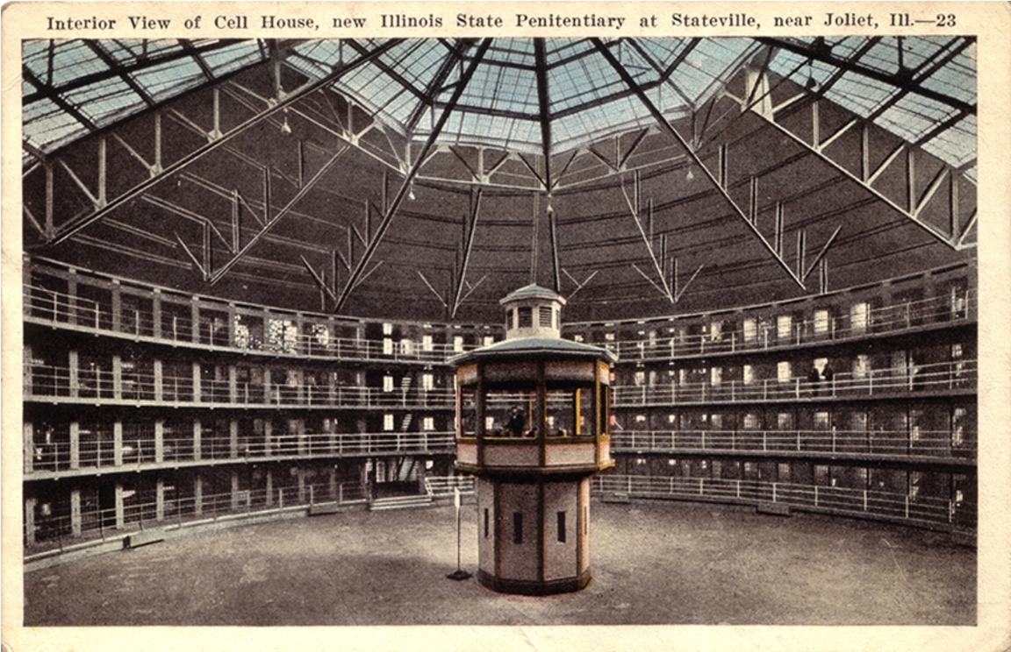

Figure X: The Panopticon Structure of the Illinois State Penitentiary

A helpful analogy for the relationship between provider and user can be seen in the design of Jeremy Bentham’s *Panopticon* (Bentham and Bozovic, 2011), pictured in Figure X: an 18th century prison architecture designed to elevate the power of the (hidden) prison guards to observe all the prisoners easily at any time while removing prisoners’ privacy and providing no ability to observe those in power. As in Orwell’s *Nineteen Eighty-Four*, individuals are unable to know when they are being watched, thus are forced into compliance. Structuralist philosopher Foucault interpreted the Panopticon as a political design, recognising that human environments can be configured to influence or regulate behaviour, in order to defend the power of the ruling class (Foucault, 1975). Such designs embody his four principles:

* **Pervasive Power**: the guards see everything all the prisoners do, all the time
* **Obscure Power**: the guards can see into any cell at any time, but the prisoners can’t know when, how or why they are being observed
* **Direct Violence Made Structural**: the structure motivates the prisoners to self-regulate their behaviour without being coerced (through beating or punishment)
* **Structural Violence Made Profitable**: having been made compliant by the structure, the prisoners can be put to work for the benefit of those in power, as it is the only option available to them.

We can see at least three of these traits in modern Internet platforms such as Facebook today: these platforms monitor user behaviour (pervasive power) without their knowledge and without accountability (obscure power). Interfaces are designed to offer only those actions that benefit the platforms (for example, clicking ads or spending more time on site (structural violence made profitable). This has happened through the processes of *platformisation* and *infrastructurisation* (Helmond, 2015; Plantin *et al.*, 2018), which have supplanted the Web 2.0-era promise of a free, open Internet that could be a great leveller and empower individuals.

Through the control of both the data, and the design of the interfaces through which the data is made available - and the only channel through which they can be observed, **service providers and platforms assert a structural power over the digital landscape**. Just as the design of the panopticon regulates the behaviour of the prisoners, so the configuration of the platforms, apps and service interfaces we use regulate and limits the behaviour of users. As Lessig wrote, ***‘Code is law.’*** (Lessig, 2000). This infrastructural power is explained further in the insight below.

Looking deeper into theories of power reveals that structural power is not the only form of power which modern-day data-centric service providers hold. Jasperson *et al.*’s extensive review of types of power in the context of technology organisations identifies 23 different power paradigms, of which at least 13 can be, and are, asserted by data-centric organisations today:

* ***authority***: ownership of technology or infrastructure (for example of websites, servers and code)
* ***resource control***: controlling the flow of resources (in this case of information/data)
* ***systems/structural power*** structural manipulation of others (as detailed above)
* ***rational power***: controlling decision-making processes
* ***disciplinary power***: using an influential position to affect others’ mental models (for example, positioning location tracking as theft resilience
* ***zero sum power***: winning a battle for ownership/resource control at the other party’s expense (e.g. losing control of your sacrificed data)
* ***behavioural influence***: persuading others to carry out the desired behaviour (e.g. restricting features to motivate subscription payments)
* ***interpretative influence***: determining how reality is externally represented (e.g. Facebook determining the way in which your social network is represented to you)
* ***network centrality***: becoming an indispensable hub of a wider ecosystem (for example, Facebook/Google dominance in online ad-brokering)
* ***processual power***: changing processes for competitive advantage (for example, platforms offering preferential APIs or rates to compliant partners)
* ***socially shaped power***: influencing a wide audience to settle upon a preferred interpretation (e.g. using dominant market position to dominate debates e.g. about privacy norms)
* ***interpretive power***: creating the internal representations of reality within an organisation (for example, presenting unpopular attitudes to data privacy to staff as normal/acceptable/beneficial for business)

| INSIGHT: The Four Levers of Infrastructural Power |
| --- |
| Hestia.ai [7.1.1] have produced a model to explain the mechanisms by which powerful technology companies gain power and use it to shape today’s digital landscape. This model is illustrated in Figure X, and shows that ***infrastructural power*** comes from three things: *technical ability*, *organisational ability*, and *the acquisition of data about individuals and populations*. Thus, as organisations (especially platforms) collect more data, and grow in market influence or technical capability, they gain power over individuals and over other organisations. They exert power in four quadrants, using four ‘levers’. Simplified and expressed in the terms of this thesis, these are: |
| 1. **Collect & Interpret Data to Acquire Knowledge**: Data and signals are collected from individuals and interpreted in order to infer their intents and interests. For example, Google collects raw GPS and wi-fi hotspot data from mobile phones, which it then statistically analyses to infer which shops or venues you visited and what forms of transport you used, increasing Google’s knowledge about individuals and populations. |
| 2. **Present Content and Configure Structures to Influence Individual Behaviour**: Knowledge of individual intents and interests is exploited within user interfaces to influence desired individual actions. For example, Facebook or presents a user with a product relevant to their interests, which they are motivated to click upon, generating ad revenue. Another example might be Twitter manipulating the content of the user’s feed to show more tweets from conversation topics where they can show promoted tweets, increasing ad revenue. |
| 3. **Configure Structures to Improve Knowledge Acquisition**: A provider uses its dominant position is exploited to force other organisations to improve the provider’s ability to acquire knowledge. For example, Google provides free analytics tools to web developers, but requires the end users of those client websites to supply visitor data back to Google, increasing their ability to acquire knowledge about individuals and populations. |
| 4. **Configure Structures to Disadvantage Others**: Certain providers (typically of operating systems or popular devices) can configure the structural relationships between other parties. For example, a smartphone manufacturer could limit data exchange between other apps, while still extensively collecting data signals themselves, such as when Google was found to be collecting call history from Android’s dialer app. |
| The precise mechanisms and techniques employed by platforms and providers when exerting their infrastructural powers, as well as the social and market consequences of these practices are explored in detail in Hestia.ai’s digipower technical reports, of which I was a co-author (Bowyer *et al.*, 2022; Pidoux *et al.*, 2022). |
| An important aspect highlighted in the research is that providers’ power is far greater than many realise: Unlike in the physical realm, providers of popular online platforms can **reconfigure the landscape to change the way that individuals perceive reality**, in line with the powers of interpretative influence, behavioural influence and socially shaped power described above (Bowyer *et al.*, 2022). Providers control the extent to which (if at all) the data stored behind the scenes, and the internal processes that use that data, are visible, and how such data and processes are represented. |
| The above model shows that the accumulation of data (and hence, information) is implicitly and objectively a form of power. This theory is consistent with participants’ observations in 5.4.4.1 that data holding and limiting access to it is a source of power. We can therefore predict that as long as current platforms and service providers are free to collect so much personal information, the information landscape will remain imbalanced and individuals will not be able to acquire ecosystem negotiability. |
| Through this insight it is clear that the most powerful data holders exert huge influence over the digital landscape, in terms of what is knowable and what is do-able. Individuals or activists’ abilities to balance the landscape are hindered by the fact that they are operating in a landscape that the incumbent platform and service providers effectively control. |

[TODO make this an inset box not a table]

The second major obstacle to the objective of ecosystem negotiability we must recognise, is that the above processes of platformisation and power exertion are not a one-off transition, but rather an ongoing process which has not ended. There is **a continuing trend of actively diminishing individuals’ agency**, especially evident in the last decade. When software was sold in a box, manufacturers competed based upon which product would let the user take home the greatest range of features and capabilities. New releases with new features drove new product sales. But in the cloud computing era, a smaller set of core features done well is sufficient to guarantee an ongoing subscription revenue from a user. Cost savings in development and support costs can be made by reducing feature sets. The relentless pursuit of increased profits and further cost saving sees products lose, not gain, features. Interfaces are reshaped to serve businesses’ interests first and foremost. As described in 2.3.5, the primary concern is about making user behaviours constrained, predictable and profitable, rather than meeting their needs or providing maximal value. Plantin *et al.* describe the particular harmful influence on the ecosystem of Facebook’s power exertions: *“Facebook a formidable force in a profit-motivated platformisation which is beginning to eat away at the Open Web. This entails moving away from published URIs and open HTTP transactions in favor of closed apps that undertake hidden transactions with Facebook through a Facebook-controlled API.”*

Here are just a few examples of the ways in which users’ agency has been, and continues to be, diminished:

* Facebook closed their RSS feeds, and later parts of their APIs, meaning that users could no longer consume their friends’ posts in any other environment than the ad-filled and manipulated Facebook main feed. Later they removed features such as friend-list feeds and favorite-page feeds, removing users ability to compartmentalise their content viewing or focus on certain friends. The ‘Friends’ page on Facebook currently shows a list of recommended new friends; to access your current friend list requires an extra click. Encouraging users to grow their networks is prioritised over user convenience.
* Twitter closed the parts of its APIs that allowed realtime notifications and access to one’s home feed, killing off primary functionality for a health ecosystem of third party Twitter clients that gave users choice (Newton, 2018). TweetDeck, a major third party Twitter client was acquired, and later shut down, as was Twitter’s own desktop client. Eventually, the only option left to users was to use the web interface. (Gayomali, 2015; Hatmaker, 2018; Siegal, 2022)
* Apple has been diminishing users’ agency for a long time. Users cannot open up iPhones without invalidating their warranty. They have removed disk drives, headphone ports, SD card slots and other ports. Certain parts of the hard drive on macOS devices are now read-only and unwritable by users.
* Facebook recently announced that they will no longer store users’ historical location data (though they will still use location unformation) (Pegoraro, 2022). This means that users will lose the capability to access historical location records, but also this makes it harder for users to see how their location data will be used in future, as there will be no historical log to examine. This shows that data-centric companies can change their practices to limit agency and reduce accountability too.
* In an example from the public sector, through my work on the SILVER project just prior to the introduction of the GDPR in 2018, I heard whispers in local authorities of plans to ‘shift from getting data collection consent from supported families towards informing them of our practices’, showing that the instinct to further organisational interests over those of the individual is not limited to commercial data holders.
* Similarly, in 2022 TikTok announced that it would rely on legitimate interest rather than consent when it comes to using users’ activity data to personalise the app experience, removing users’ ability to withdraw consent to such use. This plan has been paused after warnings that this might breach GDPR (Lomas, 2022).

Unchecked, it is clear that trends to reduce users’ agency and further providers’ interests will continue, Therefore this trend to diminish users’ agency is a particular obstacle that would need to explicitly targeted if data interfaces are to become more free-flowing (Bowyer, 2018), and if the objective of ecosystem negotiability is to be realised. Somehow, the trend needs to be halted, before it can be reversed. Judging by the TikTok example, perhaps only regulatory changes can force such a change.

The third and final obstacle I have identified to the objective of ecosystem negotiability is **the intractable data self**. As identified in the pilot study (Bowyer *et al.*, 2018), and in Case Study Two [5.4.4.1] data about individuals serves as their proxy. It serves as their data self, and if it is incomplete, inaccurate or unfair, which is highly likely given the difficulties of representing people in data (Martin, 2007; Cornford, Baines and Wilson, 2013), this can cause harm (Bowyer *et al.*, 2018) or undermine attempts to help individuals (Cornford, Baines and Wilson, 2013). Yet currently, although some legal rights to data correction exist (Information Commissioner’s Office, 2018), people lack practical abilities to modify or assert control over the most important version of themselves as far as providers are concerned: the version of them that exists in data. Even when data can be seen (such as via a support worker or GDPR data access requests) people lack the ability to exert influence over their data self [5.5.2; Cornford, Baines and Wilson (2013)]. To address this obstacle, the most likely direction would be to explore possibilities by which people could take a role in the curation of their data self, as both Case Studies have proposed [4.4.3; 5.5.2] and 6.3 have proposed.

To conclude consideration of this objective, it is noteworthy that to date, research and innovation on personal data ecosystem negotiability has been very limited. It is much easier to find business models and research funding for specific, well-defined contexts. Only non-profit research organisations such as the BBC and Sitra have found themselves well-equipped to explore this problem space. Nonetheless, despite these challenges, there is an urgent societal need for researchers, designers, policymakers and innovators to explore how trends of diminishing agency can be reverse to involve people with their data. People need to be reconnected with their data selves, and given control over their digital lives, at the broadest level, rather than being excluded.

### 1.3.5 Obstacles to the HDR Objective of Effective, Commercially Viable and Desirable Systems

MAIN POINT: HDR faces a particular challenge in that it requires a disruptive change, which no-one is screaming for and businesses are not currently motivated to invest in. It is hard to build effective systems in this space. We need Human Centred Information Systems faster horses example / ice disruptions? INSIGHT: NEW LIFE CAPABILITIES, PAIN RELIEVERS ref value proposition canvas. BACK SELF REF: VACATION EXAMPLE SUBPOINT: LACK OF INTEROPERABILITY. SUBPOINT Companies (and pubsec orgs REF) acting in closed, introspective, non cooperative ways. Proprietary, incompatible silos Apple ecosystem. Google+ example. closed practices seen in c4. INSIGHT: WE NEED TO TEACH COMPUTERS TO UNDERSTAND INFORMATION Semantic analysis & information standards.

BACKREF SELF ANNOTATING DATA DIAGRAM LIT REF Semantic Web OUTWORLD REF: CONTENT ANALYTICS / ECM standards example : shapes library, solid. ENDING 1 - need to show business value LIT REF VRM, [add a VRM screenshot] reduced liability increased accuracy WORLDREF the drive behind the data sharing ecosystem is better knowing users. self declared interests/data self would help ENDING 2: need to show value to individuals, give a new capability or solve a problem LIT REF environment/Abowd? LIT REF Value-centred design BBC REF HUMAN VALUES BBC

## 1.4 The landscape of opportunity: Four approaches to improving Human Data Relations

### 1.4.1 An Approach to Improving HDR: Discovery-Driven Activism

MAIN POINT: To actively use the legal rights, tools and capabilities available to discover what data is collected, how it is interpreted and used, how the ecosystem functions. To work together as collectives and make COMPARISONS. OUTREF analogy of theyworkforyou OUTREF Dehaye with Facebook OUTREF my work with Spotify, Netflix SUBPOINT: The power of collectives LITREF / OUTWORLD REFs Mahieu LITREF Digipower OUTREF Feed comparison Facebook political. (mention the unionisation angle OUTREF Uber) SUBPOINT Bootstrap the Data Understanding Industry OUTREF Ethi OUTREF Hestia SUBPOINT: AUDITING DATA HOLDERS (the triangulation of law, privacy policy and examining what they do) FRAME AS DIAGRAM individuals informing/powering collectives Collectives helping individuals Using Data to Demand Change in Practice => which in turn enables individuals with stronger capabilities and better transparency & insights ENDING: there is a role for independent actors and organisation to carry out activism - complaints, legal challenges, public relations, OUTWORLD REF noyb.eu, open rights group, labour/The Citizens

### 1.4.2 An Approach to Improving HDR: Building the Human-Centric Future

MAIN POINT: Design Ideas for a Human Centric Information System, illustrated with diagrams BBCREF A central home for your personal data BBCREF modelling data as life information BBCREF Happenings Diagram Time as unifier (LITREF TIME C2). What data IS to people (ref lenses) BBCREF (backref life concepts, then: Simplified model of presenting information to users) BBCREF Dashboard example SUBPOINT Capabilities BBCREF diagram What can users do (properties) Asking questions (THESISREF C5) BBCREF taxonomy diagram BBCREF Browsing by areas of life.. leads to: SUBPOINT Mental Models > Life- level systems, life partitioning teevan. conceptual anchors 2.2.2 BBCREF cluedo rooms LITREF Lenses etc C2 SUBPOINT Approaches by automatically finding entities ref back to semantics etc. (two arrows diagram back ref’d, and the Insight about semantic understanding) (can callback the subscrab example from above here too) Extraction and Learning systems BBC REF flows for entity identification BACKREF digital agents. like an assistant. [POSSIBLY CUT?] SUBPOINT Digital Self Curation & Inclusive Data Flows Litref VRM OUTREF BBC Wired article the potential of inclusive flows (build on provenance, rivers of data, LITREF streams) FRAME AS DIAGRAM Building new designs (reaching into understanding, LITREF data enabled design and Human values) Delivering new structural capabilities. Enabling new individual and collective perspectives. ENDING: Individuals Empowered with new Life / Ecosystem Information Capabilities.

### 1.4.3 An Approach to Improving HDR: Defending Autonomy and Nurturing the Information Landscape

MAIN POINT: That it is not just about Positive Change, there must also be Defensive Action, in the face of the active erosion of user autonomy (backref above diminishing agency). That this is an avenue of activist and grassroots work in its own right. some kinda visual? LITREF guard rails for the status quo INSIGHT: THE IMPORTANCE OF SEAMS Black Box diagram LITREF Storni magical design DERC REF Seams, JustEat etc. Facebook example. That guy who got banned from Facebook for letting people read their Facebook feed in a different way AND the blocking of accessibility readers and Chrome getting reinvented List of bullets DERCREF the opportunity of scrapers & webaug LITREF right to repair SUBPOINT Surface Information Injustices. REALWORLD REF Frances Augen, Snowden, Assange.whistleblowers. but also can do this within interfaces. Build the features that should be there with a big “we can’t do this because X won’t let us” SUBPOINT promoting and developing standards, and better regulations OUTREF guidelines [GDPR guidelines I fed back on] OUTREF new European laws, DSA etc, to regulate the landscape ref back to end of C5, for policymakers FRAME AS DIAGRAM taking external *protective* action as collectives, surfacing, challenging, pushing for better enforcement of existing regulation ENDING: Seizing and holding the powers we are given and never giving them up. The price of freedom is eternal vigilance OUTWORLD ref cars OUTWORLD REF Apple OUTREF Ad blockers > Brave > facebook containers.

### 1.4.4 An Approach to Improving HDR: Winning Hearts and Minds: Teaching, Championing and Selling the Vision

MAIN POINT: That the nature of pursuing Human Data Relations causes for a radical reconfiguration of today’s data world. We need new systems (which means not only there need to be business drivers for those systems but also that existing organisations much choose or be compelled to invest in them), and people need to understand, use and see value in those systems. Therefore, there needs to be specific investment: SUBPOINT in Education, and Data Literacy SUBPOINT in Systems Building (just ee above) SUBPOINT in standards, information uniting the diaspora SUBPOINT in Researching New Business Models and Demonstrating Value of transparency and human centricity SUBPOINT in supporting Data Understanding Industry. empowering individuals as investigators. Tools to map their own ecosystems and unite their own personal data diaspora. FRAME AS DIAGRAM Structural work in upper right - standards Selling work in top level - show value to individuals Selling work in top level - show value to organisations Structural work in bottom right - systems Individual work in top left - empower and educate individuals all leading to new action of individuals in top right ENDING: that this is not just a technical problem, and not just a case of building new things. It’s about beginning and catalysing a cycle of constant feedback, of data enabled design and action research / iterative software and business model development - finding what works, championing it, selling it.

## 1.5 Thesis Conclusion

* recap HDR field as contribution
* recap the findings of the thesis and the map of the landscape
* recap the obstacles, insights and opportunities
* reiterate the answer to the main RQ
* highlight future value/societal implications of the work
* we have defined HDR. who the recursive public are (roles). what they might do… what the field is… etc
* [TODO add stuff from [here](https://workflowy.com/s/75-thesis-conclusion/5l4PUUYpf9EOGxe9)]

# Bibliography

Abiteboul, S., André, B. and Kaplan, D. (2015) *Managing your digital life with a Personal information management system*. 5. ACM, pp. 32–35. doi: [10.1145/2670528](https://doi.org/10.1145/2670528).

Allen, D. (2015) *Getting things done: The art of stress-free productivity*. Penguin.

Ananya (2020) ‘Java: Pass by value or pass by reference’, *Medium*. Available at: <https://medium.com/swlh/java-passing-by-value-or-passing-by-reference-c75e312069ed>.

Bentham, J. and Bozovic, M. (2011) *The panopticon writings*. Verso Books (Radical thinkers). Available at: <https://books.google.co.uk/books?id=VbpvDwAAQBAJ>.

Bergman, O., Beyth-Marom, R. and Nachmias, R. (2003) ‘The user-subjective approach to personal information management systems’, *Journal of the American Society for Information Science and Technology*, 54(9), pp. 872–878. doi: [10.1002/asi.10283](https://doi.org/10.1002/asi.10283).

Bogers, S. *et al.* (2016) ‘Connected baby bottle’, pp. 301–311. doi: [10.1145/2901790.2901855](https://doi.org/10.1145/2901790.2901855).

Bowyer, A. (2011) ‘Why files need to die’. Available at: <http://radar.oreilly.com/2011/07/why-files-need-to-die.html>.

Bowyer, A. (2018) ‘Free Data Interfaces: Taking Human- Data Interaction to the Next Level’, *CHI Workshops 2018*. Available at: <https://eprints.ncl.ac.uk/273825>.

Bowyer, A. *et al.* (2018) ‘Understanding the Family Perspective on the Storage, Sharing and Handling of Family Civic Data’, in *Conference on human factors in computing systems - proceedings*. New York, New York, USA: ACM Press, pp. 1–13. doi: [10.1145/3173574.3173710](https://doi.org/10.1145/3173574.3173710).

Bowyer, A. (2021) ‘Human-Data Interaction has two purposes: Personal Data Control and Life Information Exploration’. Available at: <https://eprints.ncl.ac.uk/273832#.>

Bowyer, A. *et al.* (2022) *Digipower technical reports: Auditing the data economy through personal data access*. doi: [10.5281/zenodo.6554177](https://doi.org/10.5281/zenodo.6554177).

Brest, P. (2010) ‘The Power of Theories of Change’, *Stanford Social Innovation Review*, 8(2), pp. 47–51.

Cavoukian, A. (2010) ‘Privacy by design: the definitive workshop. A foreword by Ann Cavoukian, Ph.D’, *Identity in the Information Society*, 3(2), pp. 247–251. doi: [10.1007/s12394-010-0062-y](https://doi.org/10.1007/s12394-010-0062-y).

Cornford, J., Baines, S. and Wilson, R. (2013) ‘Representing the family: how does the state ’think family’?’, *Policy & Politics*, 41(1), pp. 1–19. doi: [10.1332/030557312X645838](https://doi.org/10.1332/030557312X645838).

Crivellaro, C. *et al.* (2019) ‘Not-equal: Democratizing research in digital innovation for social justice’, *Interactions*, 26(2), pp. 70–73. doi: [10.1145/3301655](https://doi.org/10.1145/3301655).

Deckers, E. (2018) ‘Data-enabled design’, *UXDX*. Available at: <https://uxdx.com/blog/data-enabled-design/>.

Es, M. van, Guijt, I. and Vogel, I. (2015) ‘Hivos ToC Guidelines: Theory of Change Thinking in Practice’. The Hague, The Netherlands: Hivos.

‘Explainable AI: Making machines understandable for humans’ (no date). Available at: <https://explainableai.com/> (Accessed: 16 June 2022).

Foucault, M. (1975) ‘Discipline and punish: The birth of the prison’, *New York*. Pantheon Books.

Freeman, E. and Gelernter, D. (1996) ‘Lifestreams: A Storage Model for Personal Data’, *SIGMOD Record (ACM Special Interest Group on Management of Data)*. Association for Computing Machinery (ACM), 25(1), pp. 80–86. doi: [10.1145/381854.381893](https://doi.org/10.1145/381854.381893).

Gayomali, C. (2015) ‘Why twitter is killing TweetDeck’. The Week. Available at: <https://theweek.com/articles/467040/why-twitter-killing-tweetdeck>.

Gillespie, T. and Seaver, N. (2016) ‘Critical Algorithm Studies - A Reading List’. Available at: <https://socialmediacollective.org/reading-lists/critical-algorithm-studies/>.

Gitelman, L. (2013) *Raw data is an oxymoron*. Edited by Lisa Gitelman. MIT Press, p. 182. Available at: <https://mitpress.mit.edu/books/raw-data-oxymoron>.

Gurstein, M. B. (2011) ‘Open data: Empowering the empowered or effective data use for everyone?’, *First Monday*. First Monday, 16(2). doi: [10.5210/fm.v16i2.3316](https://doi.org/10.5210/fm.v16i2.3316).

Harris, T. (2013) ‘A Call to Minimize Distraction Respect Users’ Attention’. Available at: <http://www.minimizedistraction.com/>.

Hart-Davidson, W., Zachry, M. and Spinuzzi, C. (2012) ‘Activity streams: Building context to coordinate writing activity in collaborative teams’, in *SIGDOC’12 - proceedings of the 30th ACM international conference on design of communication*. New York, New York, USA: ACM Press, pp. 279–287. doi: [10.1145/2379057.2379109](https://doi.org/10.1145/2379057.2379109).

Hatmaker, T. (2018) ‘Twitter is killing its twitter for mac desktop client’. TechCrunch.

Helmond, A. (2015) ‘The platformization of the web: Making web data platform ready’, *Social media+ society*. Sage Publications Sage UK: London, England, 1(2), p. 2056305115603080.

Hoffman, W. (2014) *Rethinking Personal Data : A New Lens for Strengthening Trust*. May. World Economic Forum, p. 35. Available at: <http://www3.weforum.org/docs/WEF_RethinkingPersonalData_ANewLens_Report_2014.pdf>.

Hogan, T. (2012) *Toward a phenomenology of human-data relations*. Available at: <http://www.manovich.net/DOCS/data_art.doc,>.

Ihde, D. (1990) *Technology and the lifeworld: From garden to earth*. Indiana University Press.

Information Commissioner’s Office (2018) ‘Your data matters - Your rights’. Available at: <https://ico.org.uk/your-data-matters/>.

Jensen, C. *et al.* (2010) ‘The life and times of files and information: A study of desktop provenance’.

Jones, W. *et al.* (2006) ‘"It’s about the information stupid!": Why we need a separate field of human-information interaction’, *Conference on Human Factors in Computing Systems - Proceedings*, pp. 65–68. doi: [10.1145/1125451.1125469](https://doi.org/10.1145/1125451.1125469).

Jones, W. (2011) ‘The Future of Personal Information Management Part I: Our Information, Always and Forever’.

Karger, D. R. *et al.* (2005) ‘Haystack: A customizable general-purpose information management tool for end users of semistructured data’, in *2nd biennial conference on innovative data systems research, CIDR 2005*, pp. 13–27. Available at: <https://s3.amazonaws.com/academia.edu.documents/46870765/haystack.pdf>.

Kelty, C. M. (2008) *Geeks and Recursive Publics*. Duke University Press, pp. 27–63.

Kirven, A. (2018) ‘Whose gig is it anyway: Technological change, workplace control and supervision, and workers’ rights in the gig economy’, *U. Colo. L. Rev.* HeinOnline, 89, p. 249.

Le Dantec, C. A. (2016) *Designing publics*. MIT Press.

Lemley, M. A. (2021) ‘The splinternet’, *Duke Law Journal*, pp. 1397–1428. Available at: <https://perma.cc/92LZ-B8DN].>

Lessig, L. (2000) ‘Code is law: On liberty in cyberspace’, *Harvard Magazine*. Available at: <https://www.harvardmagazine.com/2000/01/code-is-law-html>.

Li, I., Forlizzi, J. and Dey, A. (2010) ‘Know thyself: Monitoring and reflecting on facets of one’s life’, *Conference on Human Factors in Computing Systems - Proceedings*, pp. 4489–4492. doi: [10.1145/1753846.1754181](https://doi.org/10.1145/1753846.1754181).

Lindley, S. E. *et al.* (2018) ‘Exploring new metaphors for a networked world through the file biography’, *Conference on Human Factors in Computing Systems - Proceedings*, 2018-April, pp. 1–12. doi: [10.1145/3173574.3173692](https://doi.org/10.1145/3173574.3173692).

Lomas, N. (2022) ‘TikTok ’pauses’ privacy policy switch in europe after regulatory scrutiny’. TechCrunch. Available at: <https://techcrunch.com/2022/07/12/tiktok-pauses-privacy-policy-switch/>.

Marchionini, G. (2008) ‘Human-information interaction research and development’, *Library and Information Science Research*, 30(3), pp. 165–174. doi: [10.1016/j.lisr.2008.07.001](https://doi.org/10.1016/j.lisr.2008.07.001).

Martin, M. (2007) *Research note: Representing identity and relationships in information systems*, *International Journal of Business Science & Applied Management (IJBSAM) Suggested Citation: Martin*, pp. 47–51. Available at: <http://hdl.handle.net/10419/190583https://creativecommons.org/licenses/by/2.0/uk/>.

Martin, M. (2022) ‘The trustworthy, governable platform: A concept of safe social spaces in the public network’. in prep.

Mortier, R. *et al.* (2013) ‘Challenges & opportunities in human-data interaction’, *University of Cambridge, Computer Laboratory*. Citeseer. doi: [10.5210/fm.v17i5.4013](https://doi.org/10.5210/fm.v17i5.4013).

Mortier, R. *et al.* (2014) ‘Human-data interaction: The human face of the data-driven society’, *Available at SSRN 2508051*. doi: [10.2139/ssrn.2508051](https://doi.org/10.2139/ssrn.2508051).

MyData (2017) ‘Declaration - MyData.org’. Available at: <https://mydata.org/declaration/> (Accessed: 8 November 2019).

Neff, G. (2013) ‘Why Big Data Won’t Cure Us’, *Big Data*, 1(3), pp. 117–123. doi: [10.1089/big.2013.0029](https://doi.org/10.1089/big.2013.0029).

Newton, C. (2018) ‘Twitter officially kills off key features in third-party apps’. The Verge. Available at: <https://www.theverge.com/2018/8/16/17699626/twitter-third-party-apps-streaming-api-deprecation>.

‘Open rights group: Who we are’ (no date). Available at: <https://www.openrightsgroup.org/who-we-are/> (Accessed: 16 June 2022).

Pegoraro, R. (2022) ‘Facebook will soon stop tracking your location and delete your location history’, *Fast Company*. Available at: <https://www.fastcompany.com/90750241/facebook-will-soon-stop-tracking-your-location-and-delete-your-location-history>.

Pidoux, J. *et al.* (2022) *Digipower technical reports: Understanding influence and power in the data economy*. doi: [10.5281/zenodo.6554155](https://doi.org/10.5281/zenodo.6554155).

Plantin, J. C. *et al.* (2018) ‘Infrastructure studies meet platform studies in the age of google and facebook’, *New Media and Society*. SAGE Publications Ltd, 20, pp. 293–310. doi: [10.1177/1461444816661553](https://doi.org/10.1177/1461444816661553).

‘Recursive Public (Discussion Page)’ (no date). Available at: <https://wiki.p2pfoundation.net/Recursive_Public> (Accessed: 16 June 2022).

Siegal, J. (2022) ‘Twitter is killing TweetDeck for mac on july 1st and everyone’s angry’. BGR. Available at: <https://bgr.com/tech/twitter-is-killing-tweetdeck-for-mac-on-july-1st-and-everyones-angry/>.

Taplin, D. H. and Clark, H. (2012) ‘Theory of change basics: A primer on theory of change’, *ActKnowledge*, p. 9. Available at: <http://www.theoryofchange.org/wp-content/uploads/toco_library/pdf/ToCBasics.pdf>.

Taylor, L. (2017) ‘What is data justice? The case for connecting digital rights and freedoms globally’, *Big Data and Society*, 4(2). doi: [10.1177/2053951717736335](https://doi.org/10.1177/2053951717736335).

Teevan, J. B. (2001) ‘Displaying dynamic information’, in *Conference on human factors in computing systems - proceedings*, pp. 417–418. doi: [10.1145/634067.634311](https://doi.org/10.1145/634067.634311).

Vlachokyriakos, V. *et al.* (2016) ‘Digital civics: Citizen empowerment with and through technology’, *Conference on Human Factors in Computing Systems - Proceedings*, 07-12-May-, pp. 1096–1099. doi: [10.1145/2851581.2886436](https://doi.org/10.1145/2851581.2886436).

Weiser, M. (1991) ‘The computer for the 21st century’, *Scientific American*, 265(3), pp. 94–105. doi: [10.1145/329124.329126](https://doi.org/10.1145/329124.329126).

Windeyer, R. C. (2021) *Black box exposures: Enriching public engagement with human-data relations through intermedial performance strategies*.

1. Diagram used here unchanged from *Hivos ToC Guidelines* (Es, Guijt and Vogel, 2015, p. p90) under a CC-BY-NC-SA 3.0 license, whose authors state that this diagram was adapted from earlier work by Wilber (1996), Keystone (2008) and Retolaza (2010, 2012).
2. The group of HCI researchers involved in this panel were (with the exception of Raya Fidel) seemingly unaware of the existing HII field in library sciences as they positioned the publication as a call for a ‘new field’.
3. Of course, there is some overlap; the reason that organisations hold data is so that they can interpret it (usually algorithmically) to inform decision-making. In this way, organisations could be seen to be doing LIU of service users’ lives for their own benefit. From a human-centric perspective, this grey area is situated as part of PDEC, as from the individual perspective, how organisations understand you through information will inform decisions that affect your life. Thus, this can be considered part of the reason why one might want to exert control over use of your data, rather than being part of exploiting data to gain self-insights and personal benefits.
4. The illustrated processes assume reliance on existing data access processes such as GDPR, where the only access is through provision of a copy of one’s data. This is in fact, not ideal, as it creates divergent versions and will quickly become out-of-sync, however for the sake of simplicity this inefficiency is ignored here. Improvements upon this approach are explored in [INSERT REF]
5. The word *‘diaspora’* is typically used with reference to populations, but is an apt term, derived from the Greek *‘diaspeirein’* meaning *‘scattered about’* or ’*dispersed’*.